Housing Story Charts

# Phase 1

## Chart 1

Figure 1: Growth in population and households 1991-2016.

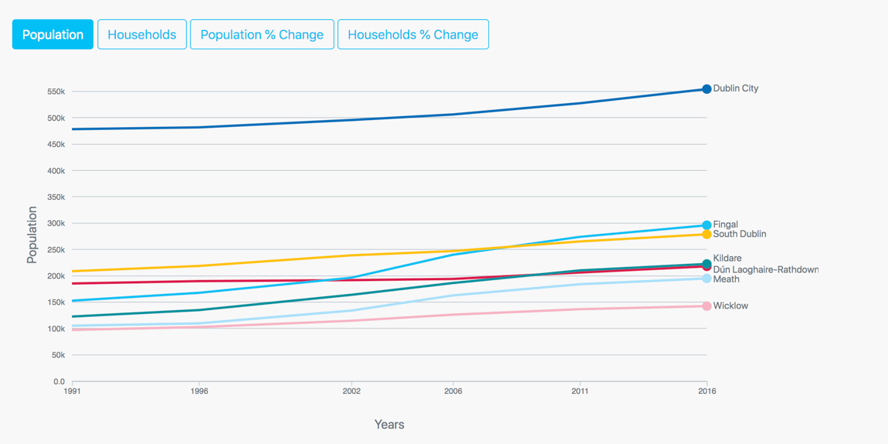

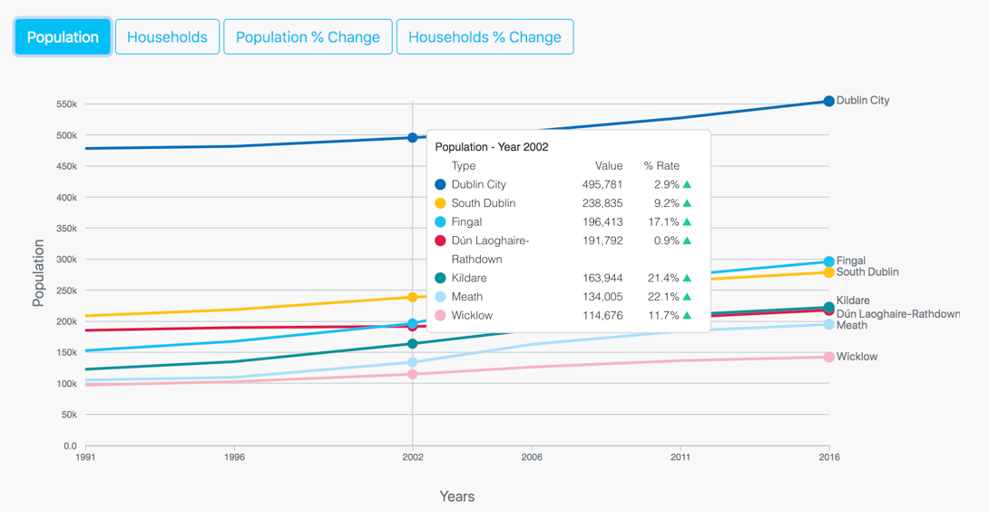

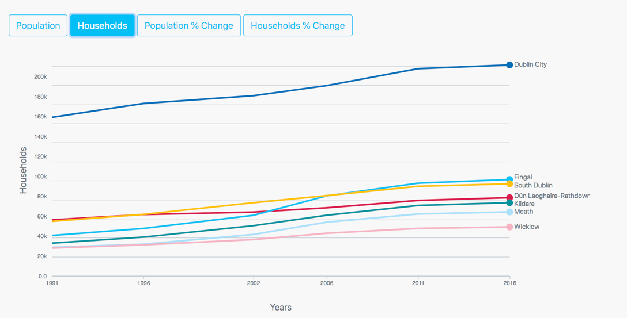

### Issues 1:

None!

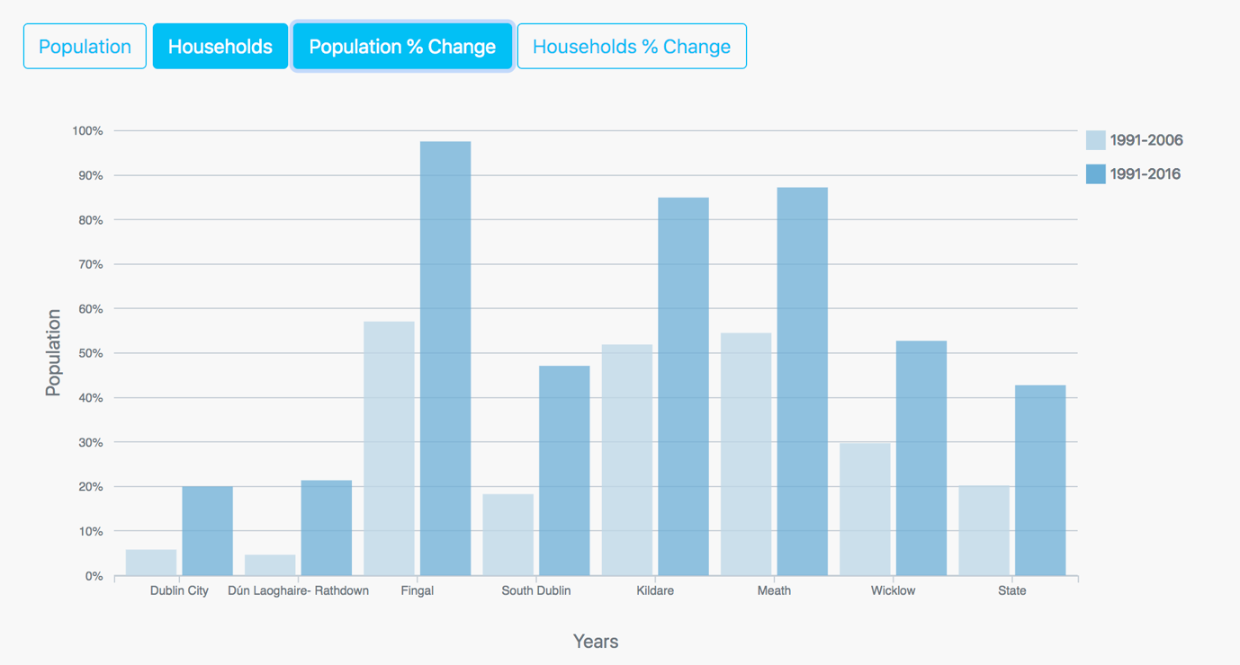

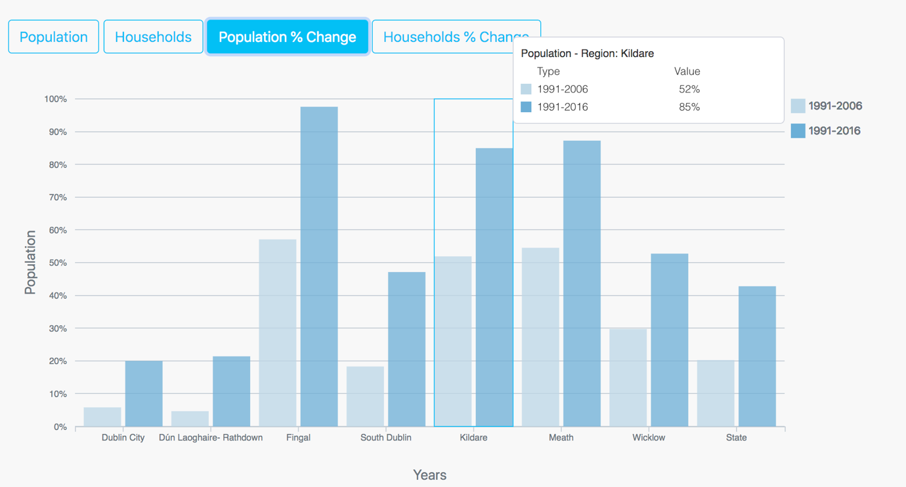

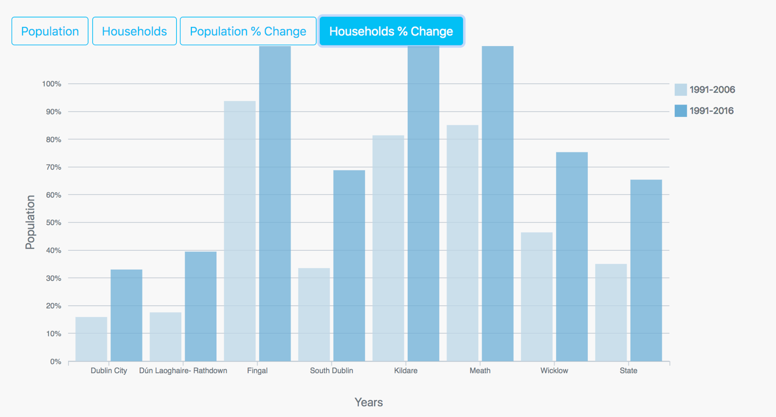

### Issues:

Bars as used not suitable for time series data, rate of change

## Chart 2

Figure 2: Housing types.

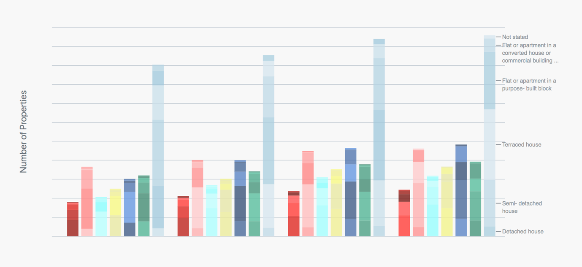

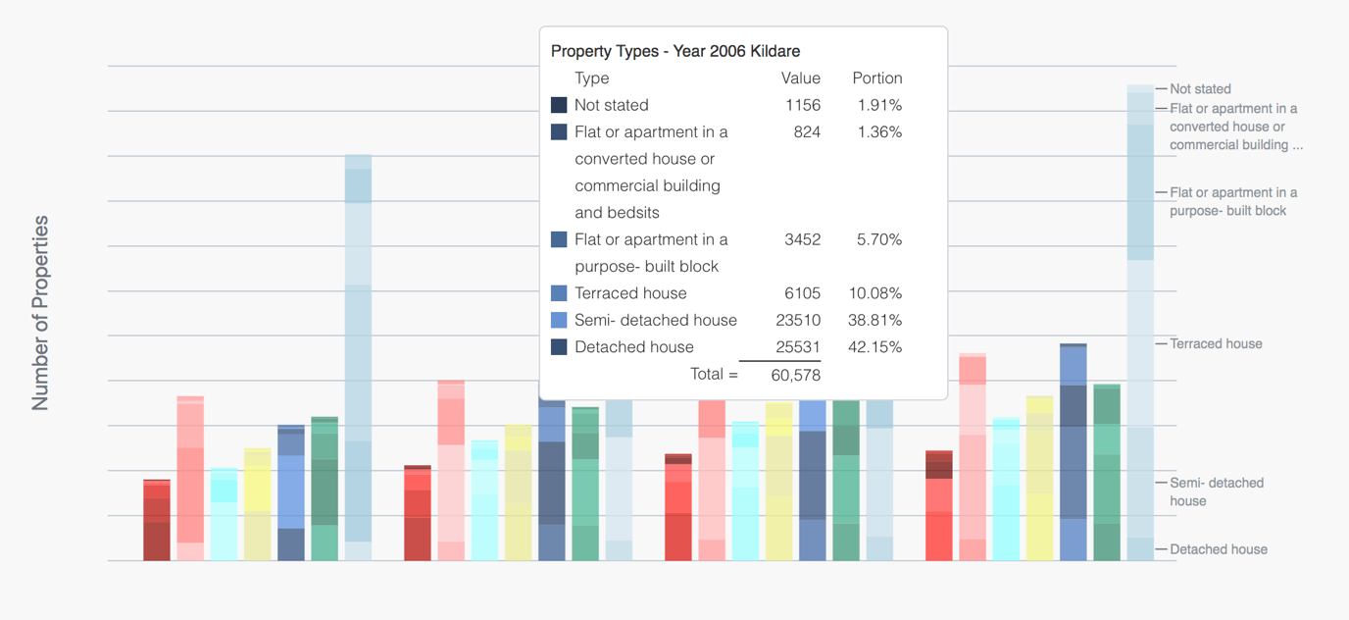

## Chart 3

Figure 3: Number of housing completions 1991-2018, Dublin, Kildare, Meath, Wicklow & National.

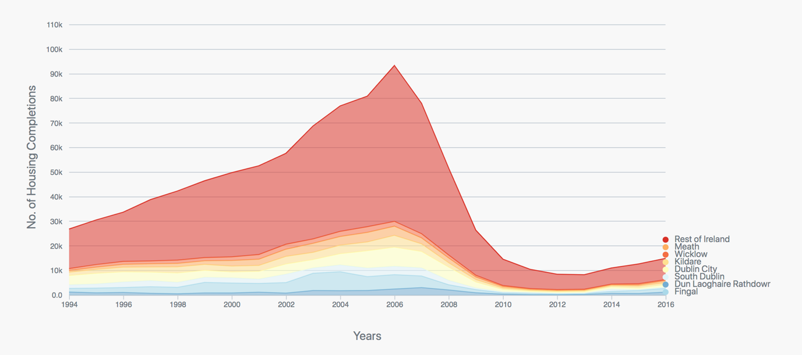

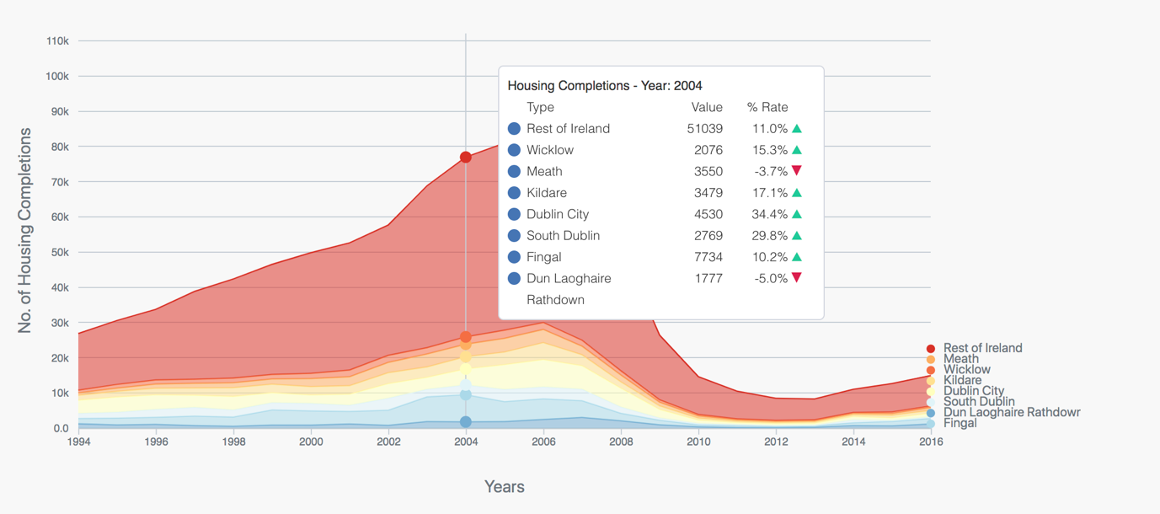

## Chart 4

Figure 4: Property price growth for Dublin/National.

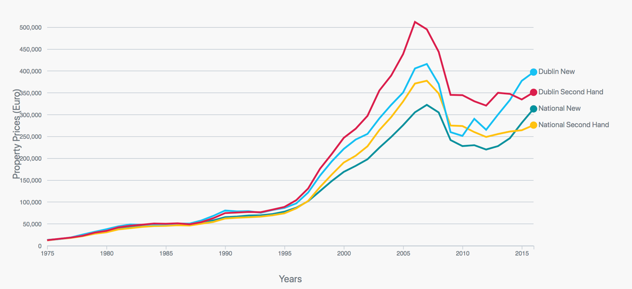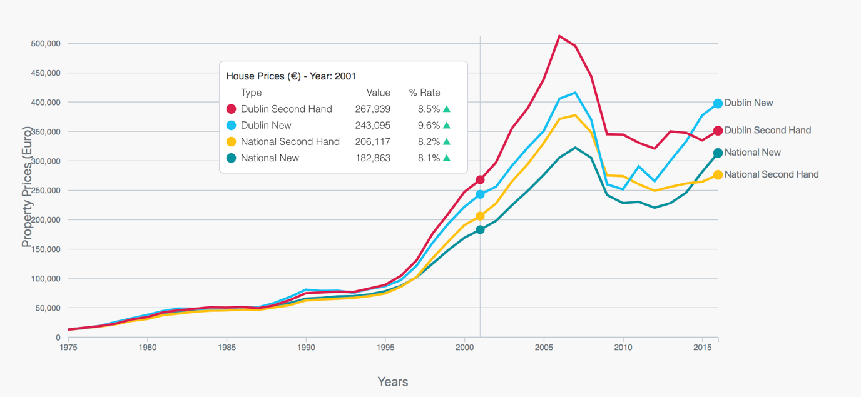

## Chart 5

Figure 5: Residential mortgage debt.

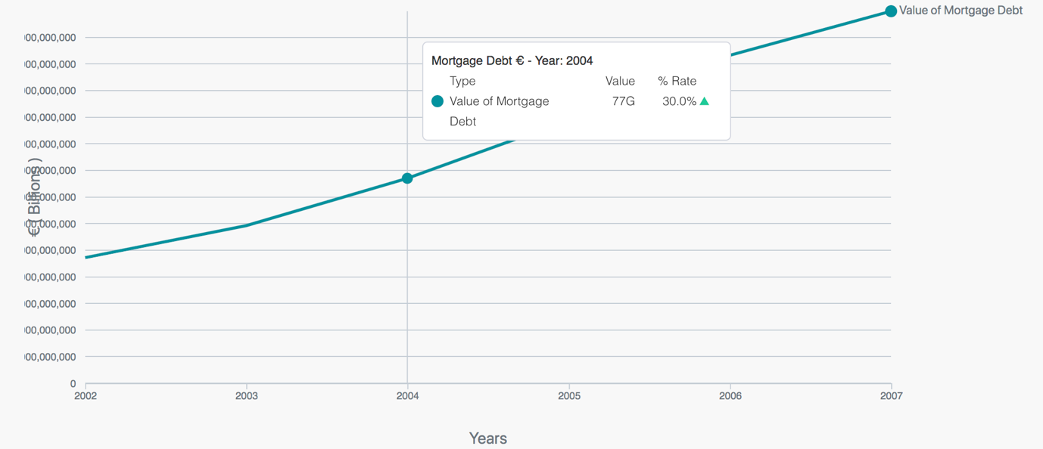

## Chart 6

Figure 6: Social housing stock vs private vs rented.

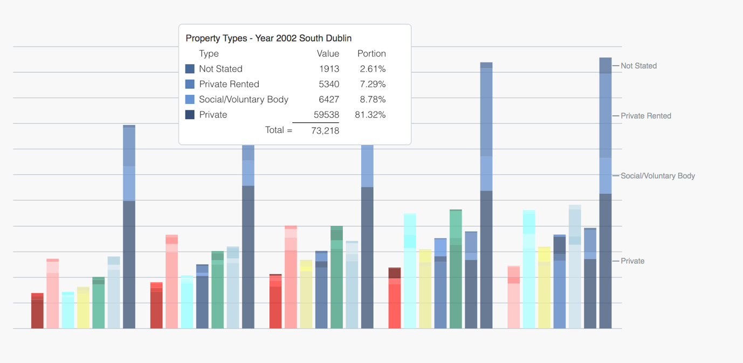

## Chart 7

Figure 7: Social housing units build or acquired through purchase, or long-term leases, and sold.

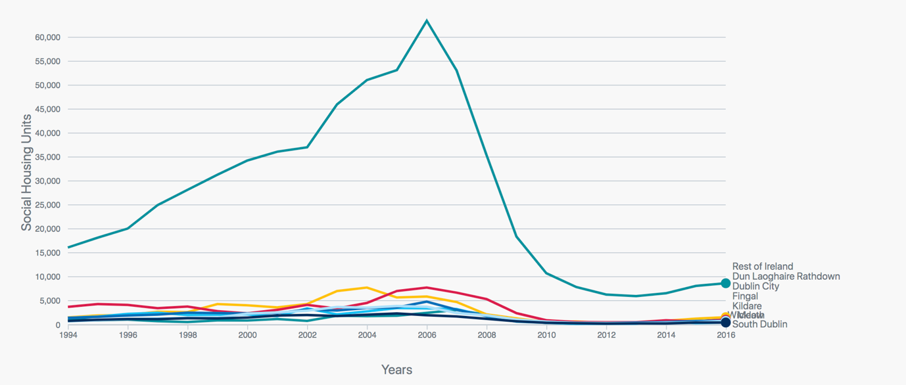

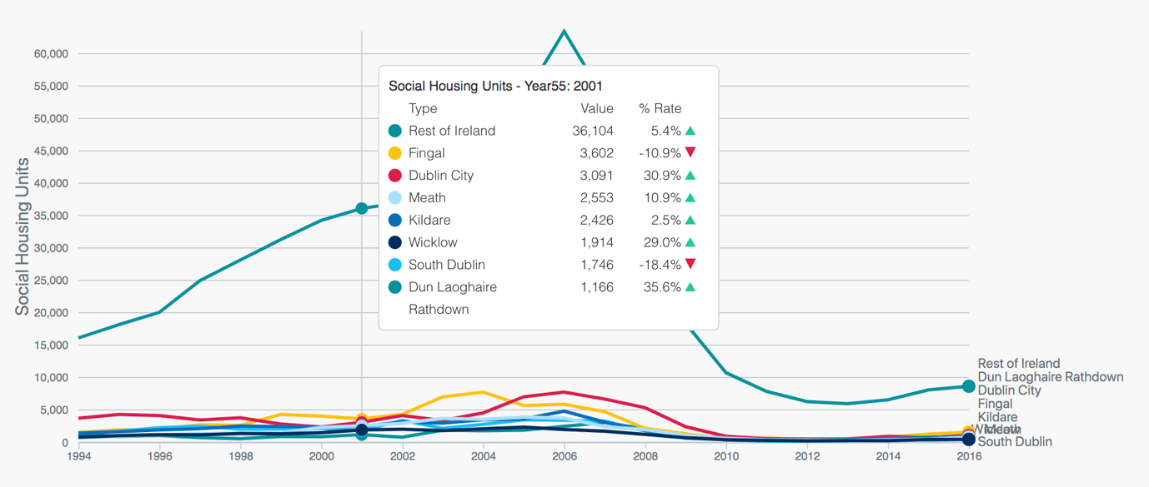

## Chart 8

Figure 8: Map of EDs with percentage of commuters travelling to Dublin to work.  
*Excludes workforce where destination was classed as 'Blank' or 'Mobile'. **Destination is based on CSO Settlement boundaries.

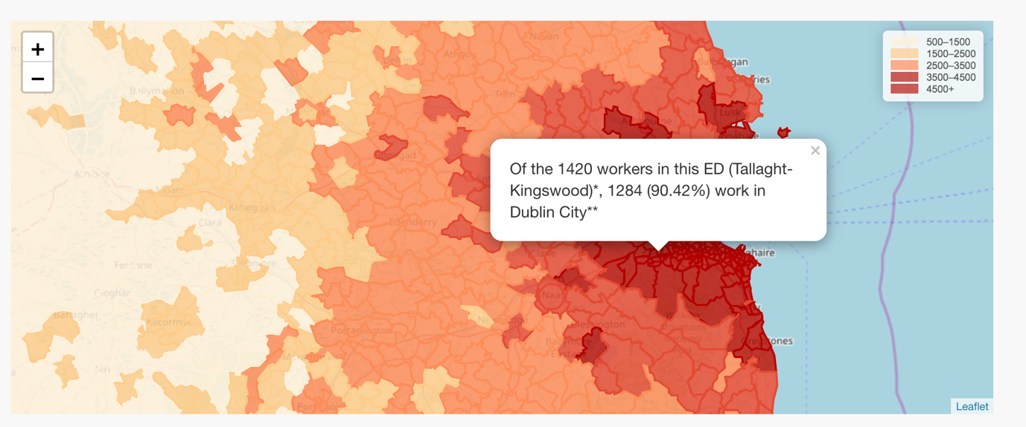

## Chart 9

Figure 9: Property tax revenue.

